ENGLISH 7 - UNIT 7: TRAFFIC

I. Find the word which has a different sound in the part underlined.
1. | A. | car | B. | date | C. | lazy | D. | hate
2. | A. | train | B. | wait | C. | said | D. | paid
3. | A. | sailing | B. | railway | C. | brainstorm | D. | captain
4. | A. | safety | B. | chat | C. | taste | D. | waste
5. | A. | centre | B. | let | C. | belt | D. | security
6. | A. | safety | B. | traffic | C. | station | D. | plane
7. | A. | seat | B. | head | C. | heavy | D. | weather
8. | A. | head | B. | break | C. | bread | D. | heavy
9. | A. | maid | B. | wait | C. | said | D. | sail
10. | A. | hey | B. | grey | C. | honey | D. | obey
11. | A. | lake | B. | came | C. | station | D. | start
12. | A. | seatbelt | B. | bread | C. | ahead | D. | healthy
13. | A. | nature | B. | ancient | C. | radio | D. | village
14. | A. | enter | B. | mention | C. | vehicle | D. | helicopter
15. | A. | take | B. | mistake | C. | indicate | D. | says
16 | A. | traffic | B. | pavement | C. | plane | D. | station
17. | A. | recycle | B. | vehicle | C. | helicopter | D. | reverse
18. | A. | sign | B. | mistake | C. | triangle | D. | drive
19. | A. | nearest | B. | head | C. | bread | D. | health
20. | A. | railway | B. | mail | C. | sail | D. | captain
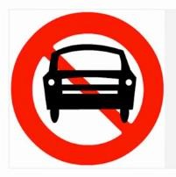
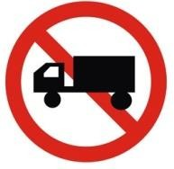

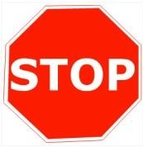
II. Match the road signs with their meanings, and then write the correct answer in the blanks.
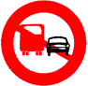
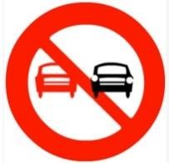
A B C D
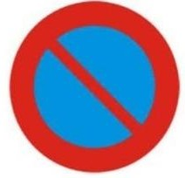

E F G H

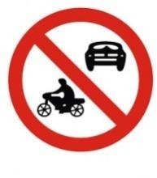
J
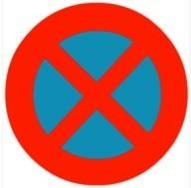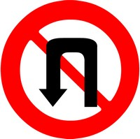
I J K M

1. No U-turns
2. Go left only
3. Go right only
4. No Parking
5. Cars prohibited
6. Stop
7. Go ahead only
8. Overtaking prohibited
9. Truck prohibited
10. All motor vehicles prohibited
11. Overtaking prohibited for trucks
12. No stopping & No Parking
III. Put the words into two groups (/e / and / ei /)
safety | way | internet | red | ahead
melody | wait | break | lane | bed
/ e / | / ei/

IV. Choose the best answer (A, B, C or D).
1. |  | Cyclist and motorist have to wear a _________when they ride a motorbike.
 |  | A. |  | cap |  |  | B. | mask | C. |  |  | helmet |  |  |  | D. |  | hard that
2. |  | He forgot to give a before he turned left and got a ticket.
 |  | A. |  | hand |  |  | B. | signal | C. |  |  | sign |  |  |  | D. |  | light
3. |  | All of us have to obey strictly.
 |  | A. |  | traffic |  |  | B. | traffic rules | C. |  |  | traffic jam |  |  |  | D. |  | regular
4. |  | We should wait for the traffic lights __________before we cross the street.
 |  | A. |  |  | turn yellow |  |  |  | C. |  |  |  | turn green
 |  | B. |  |  | to turn yellow |  |  |  | D. |  |  |  | to turn green
5. |  | Drivers have to your seatbelt whenever they drive.
 |  | A. |  | tie |  |  | B. | fasten | C. |  |  | put on |  |  |  | D. |  |  |  |  |  | put
6. |  | We should the street at the zebra crossing.
 |  | A. |  | walk |  |  | B | walk through |  |  |  |  | C. |  | walk on |  |  |  |  |  | D.. | walk across
7. |  | __________is it from your house to the nearest bus stop?” – “about 50 metres”.
 |  | A. |  | How much |  |  | B. | How long | C. |  |  | How far |  |  |  | D. |  | How often
8. |  | Linh used to __________jigsaw puzzles in his spare time.
 |  | A. |  | do |  |  | B. | does | C. |  |  | doing |  |  |  | D. |  | did
9. |  | Public in this city is quite good, and it’s not expensive.
 |  | A. |  | vehicle |  |  | B. | travel | C. |  |  | transport |  |  |  | D. |  | journey
10. |  | I marbles when I was young, but now I didn’t.
 |  | A. |  | play |  |  |  |  | C. |  |  |  | used to play
 |  | B. |  | have played |  |  |  |  | D. |  |  |  | didn’t use to play
11. |  | There ____a bus station in the city centre, but it has been moved to the suburbs.
 |  | A. |  | were |  |  | B. | used to have |  |  | C. |  |  | use to have |  |  | D. |  |  | used to be
12. |  | _________does it take to go from Hanoi to ho chi minh city by plane?
 |  | A. |  | How much |  |  | B. | How many | C. |  |  | How long |  |  |  | D. |  | How far
13. |  | Minh used to__________ his homework late in the evening.
 |  | A. |  | do |  |  | B. | does | C. |  |  | doing |  |  |  | D. |  | did
14. |  | If people the rules, there are no more accidents.
 |  | A. |  | follow |  |  | B. | take care of | C. |  |  | obey |  |  |  | D. |  | remember
15. |  | You should _________right and left when you go across the road.
 |  | A. |  | see |  |  | B. | look | C. |  |  | be |  |  |  | D. |  | take
16.. | Hurry up or we can’t the last bus home.
 | A. |  | keep |  |  | B. |  | follow |  | C. |  | go |  |  |  | D. |  |  | catch
17. | Lan used to go to school .
 | A. |  | with bike |  |  | B. |  | by foot |  | C. |  | in car |  |  |  | D. |  |  | by bus
18. | Public in my town is good and cheap.
 | A. |  | travel |  |  | B. |  | journey |  | C. |  | tour |  |  |  | D. |  |  | transport
19. | When there is a traffic jam, it ______me a very long time to go home.
 | A. |  | takes |  |  | B. |  | costs |  | C. |  | spends |  |  |  | D. |  |  | lasts
20. | Yesterday rick and peter _________round west lake. It took them an hour.
 | A. |  | cycle |  |  | B. |  | cycles |  | C. |  | cycling |  |  |  | D. |  |  | cycled

V. Fill each blank with a word from the box.
accidents | break | vehicle | across | did
rules | it | feels | after | ride

1. What __________ you do last Sunday?
2. I stayed at home and looked __________my younger brother yesterday.
3. He lives in a small village in the mountains, so he never ___________ worried about traffic jams.
4. You should remember to walk ____________the streets at the zebra crossings.
5. Does your bike ever _____________down on the way to school?
6. We must always obey traffic ________________for our safety.
7. How far is_________ from your house to the bus stop?
8. There did not use to be many_______________ on the roads in my hometown.
9. He used to _______________a tricycle when he was three years old.
10. Now there are more traffic ________________than there used to be in this city.
VI. Complete the second sentence so that it has a similar meaning to the first.
1. Did you often go to the beach when you lived in Nha Trang?
Did you use……………………………………………………………….……………..
2. Linda doesn’t live with her parents any more.
Linh used………………………………………………………………….……………..
3. I don’t have time to collect stamps as when I was in primary school.
I used to ………………………………………………………………………………..
4. He is not a poor man any more, but he becomes a rich businessman.
He used ……………………………………………………………………………………
5. They didn’t often go to the cinema every Sunday last year.
They didn’t use to……………………………………………………………………….
6. My hair now is much longer than that in the past.
In the past my hair used to………………………………………………………………….
7. I usually stayed up late to watch football matches last year, but now I don’t.
I used..................................................................................................................................
8. There were some trees in the field, but now there aren’t any.
There used ………………………..…………………………………………………………..

